

**Don’t Panic – an e-commerce application**

**Technical Web Application Specification**

**Margaret Egan**

**Katarina Hrgovic**

**Gavin Hanna**

**Cornelia Vos**

Technical Web application specification

Table of Contents

Landing Page 3

Site navigation 4

Store 5

Login Page 6

Shopping Cart Page 7

Payment Page 8

Shipping Page 9

My Account Page 10

Registration Page 11

Databases 12

Workflow Diagram 13

## Landing Page

The Landing Page will welcome the visitor into the Hitchhiker’s Galaxy by showing ‘Don’t Panic’ in big letters, as per the Douglas Adams book. The backdrop will be a picture of space, to introduce the concept that the visitor has entered the intergalactic galaxy and can purchase items in the webshop to help them on their journey.

The Home Page feature three navigation buttons: Home, Store and About.



Figure 1 Landing Page

Clicking on the ‘Home’ button on the home page will open a page with a Vogon poem.   
In the Douglas Adams book Vogon poetry is only the third worst in the universe.

From this page, the visitor can continue to the store and about page.

## Site navigation

The site navigation menu will be featured at the top of all pages except the landing page and will be fluid to make it accessible to visitors using different devices (mobile/tablet/desktop). On smaller screened devices, a hamburger will appear, and be clickable to display the navigation. By freeing up screen real estate for pertinent material on smaller screens, and keeping the navigation menu within easy reach, it should be more user-friendly.

Features of the site navigation menu:

* Search Function will be included in the site navigation menu, allowing the visitor to search for a specific item or category of items.
* Login, redirecting to a login page
* Register, redirecting to a registration page
* My account, redirecting to a page with the customer’s details
* Store, redirecting to the store page
* Shopping cart, redirecting to the customer’s cart
* Contact us, redirecting to the contact page
* About, redirecting to page containing company philosophy and staffing

Product Pages (View Products)

The product pages will display the full product details, along with images and pricing information. This will be a template which will be applied pulling the data from the system database.

## Store

Users of the ‘Don't panic’ website can access information about available products without registration.

The store page features images, prices and description of each product.

Search functionality will be enabled.

Products may be listed by price (high to low and vice versa), by product type (e.g. ‘Babel Fish’, ‘Towel’) or by name.

Users have the option of sharing a product-link via email or social media.

A customer will be prompted to log in upon adding their first product to the shopping cart if not already logged in. The prompt will be in the form of a clickable card. Clicking the button will redirect the customer to the login page.

A customer won’t be able to add items to their basket without either login or registration. This will be mentioned on the card. The customer can however click away the card and continue viewing products.

Adding an item to the basket will create an open order with a recognised user.

Once a user adds an item to a cart, they are shown a clickable message informing them they have added an item to their cart. The card contains 2 buttons: ‘continue shopping’ and ‘go to cart’.

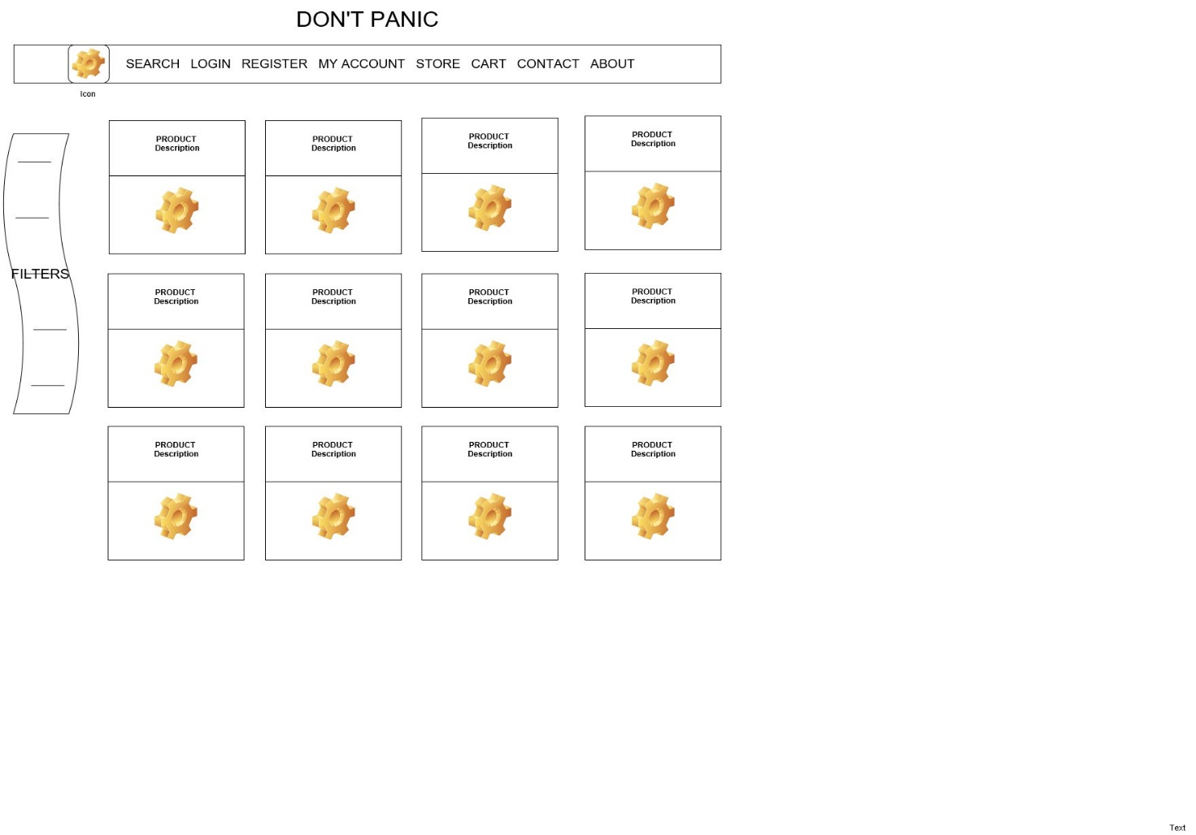

Figure 2 store wireframe

## Login Page

The Login Page contains a card which prompts the customer to enter their email address and password.

If correct credentials are entered a prompt will appear saying ‘you are logged in’ and the customer is redirected to the store page.

If incorrect credentials are entered a prompt will appear saying ‘incorrect email or password’.

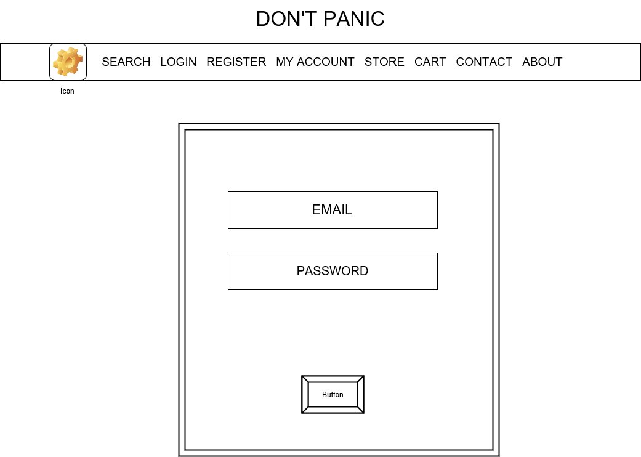

Figure 3 Login page wireframe

## Shopping Cart Page

The Shopping Cart Page can’t be accessed until a customer is logged in.

The page shows all items added via the ‘buy item’ button on the Store Page.

Each item in the cart has the following buttons:

* Change quantity -> changes the quantity of that product order (cannot be 0)
* Remove item -> deletes product from basket
* Save for later -> deletes product from basket and stores it in a new table in the customer account page

On the bottom of the page there is a ‘confirm order’ button. Once the customer presses this button, they are taken to the payment portal.

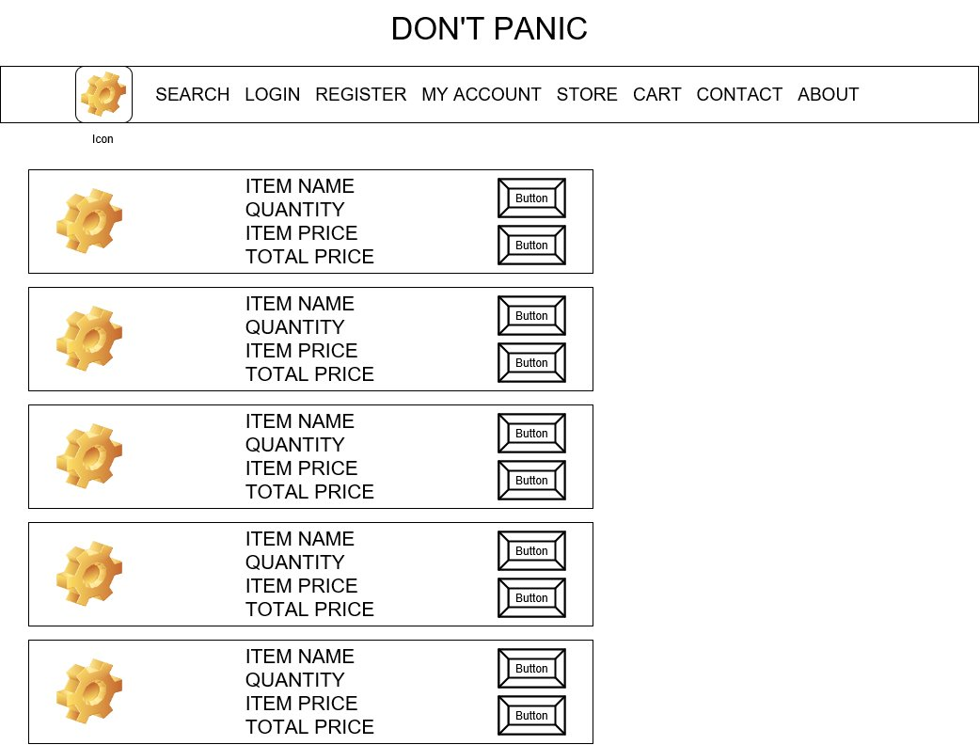

Figure 4 Cart wireframe

## Payment Page

The Payment Page contains a form with a dropdown menu where a customer can:

* Choose their payment method (card or PayPal)
* Enter their card details

If a customer chooses PayPal as their payment method, they are redirected to the PayPal portal to complete their purchase.

If a customer chooses card as a payment method they must complete their card details.

Once all fields are completed and the customer clicks on the ‘submit’ button, contact is made with an external payment operating system to verify payment.

* If the transaction is confirmed by the POS, users are redirected to the Shipping Page.
* If the transaction is not confirmed, the Payment Page will reload and a message will appear ‘payment failed, please resubmit your details or choose another payment option’.

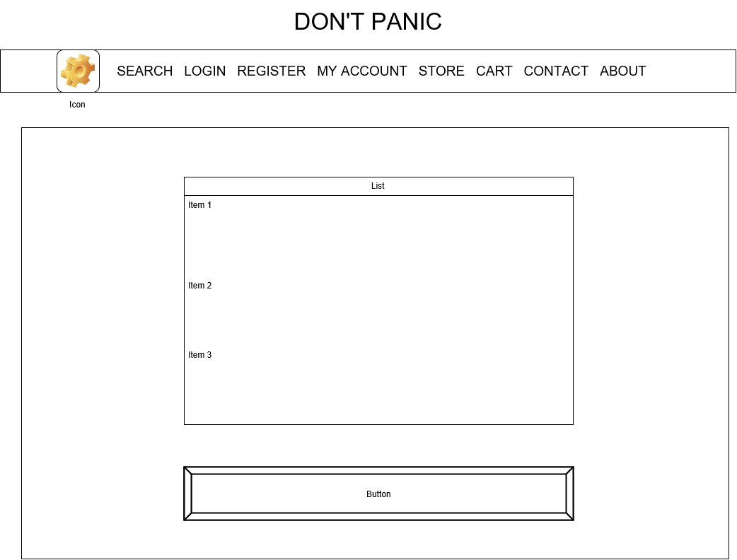

Figure 5 Payment Page Wireframe

## Shipping Page

The Shipping Page will Have a Text Box on top of the page containing:

* Confirmation of successful payment
* Order Number

Underneath that it will have a box containing the shipping address linked to the customer number of the customer placing the order. It will have a button asking to confirm the shipping address and a button saying, ‘update shipping address’.

* If customer confirms the shipping address to be correct, a message will appear on screen confirming the order will be shipped to this address.
* If the customer clicks the ‘update shipping address’ button, the address fields can be overwritten, allowing for a customer to update each field. Once updated, they click the ‘confirm shipping address’ button.

After clicking ‘confirm shipping address’ a message will appear containing:

* Expected shipping date
* Expected duration of shipping
* A button with a link to the Landing Page

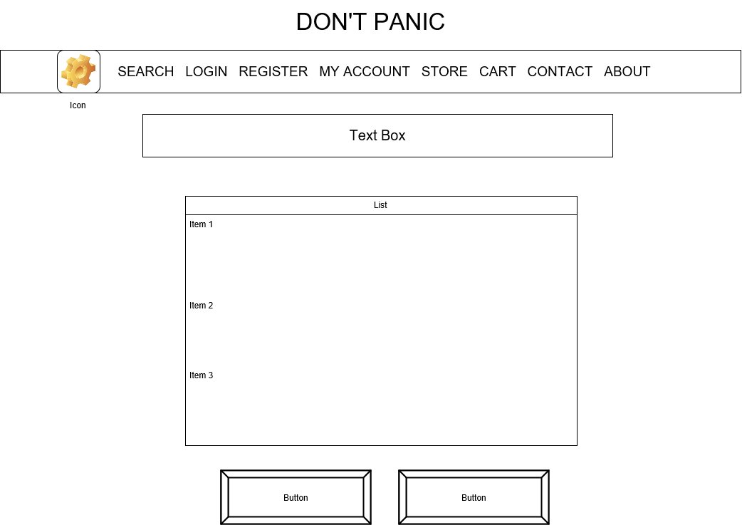

Figure 6 Shipping Page Wireframe

## My Account Page

The Account Page provides a customer with the following information:

* Customer Number
* Order Information
* Shipping Address (+update)
* Email (+update)
* Phone Number (+update)
* List of items saved for possible future purchase (+update and move to cart)

The account page is only visible after a customer logs into their account.

The customer is able to update their shipping address, email address and phone number by clicking the ‘update’ button underneath these fields, which allows the customer to overwrite the current values upon saving, the database containing the customer’s details will automatically be updated.

The Account Page also contains a list of items the customer has saved for possible future purchase.

Each of these items can be moved to cart or deleted.

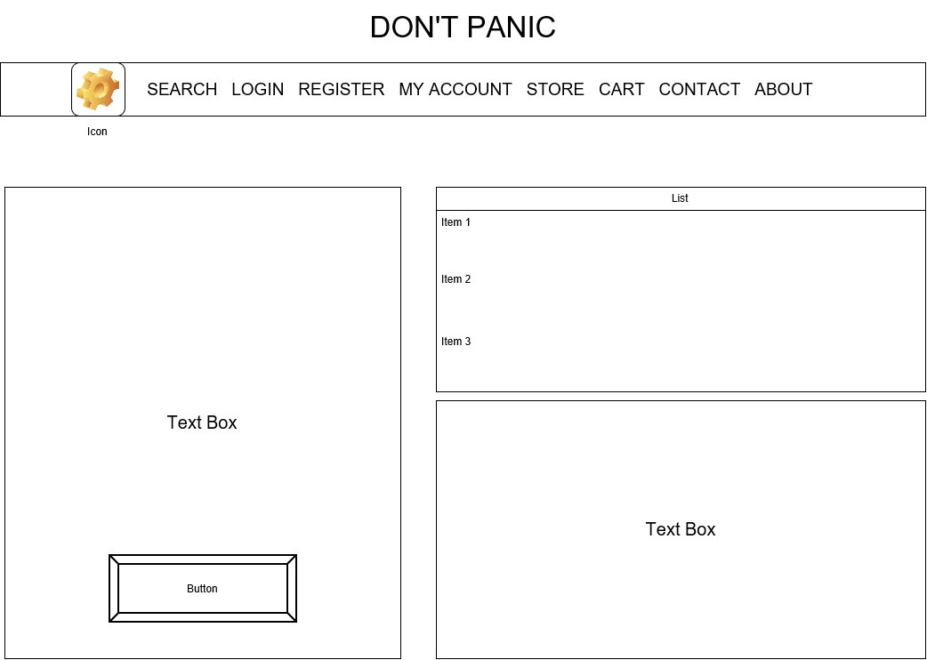

Figure 7 Account Page wireframe

## Registration Page

The registration page contains a form with the following mandatory fields:

* First Name
* Last Name
* Address Line 1 (street+housenumber)
* Address Line 2 (town+postcode)
* Address Line 3 (country)
* Email Address
* Phone Number

The customer needs to fill out all the required fields.

After filling out the form they can save their information clicking the ‘save’ button.

Once the customer clicks this button, a new record is created in the customer database and an Account Page is generated for the customer, as well as a customer number assigned.

The registration page also contains a text box outlining the terms and conditions of site use.

The customer needs to click the button saying they understand the T&C’s before the their record can be created.

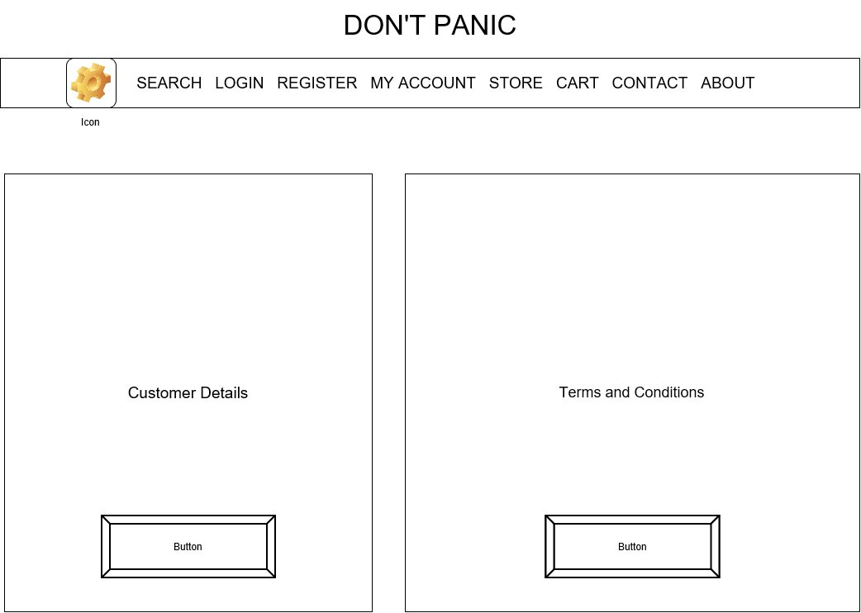

Figure 8 Registration Page wireframe

# Databases

In order to store all information to make the site functional, the following databases need to be created:



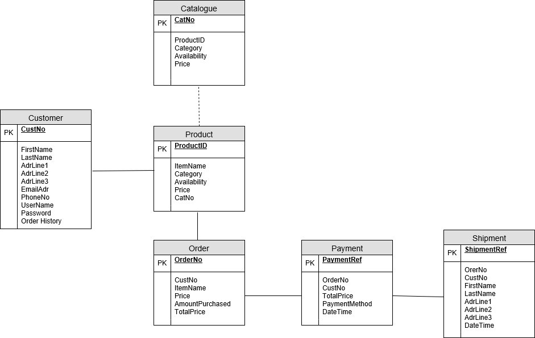

# Workflow Diagram

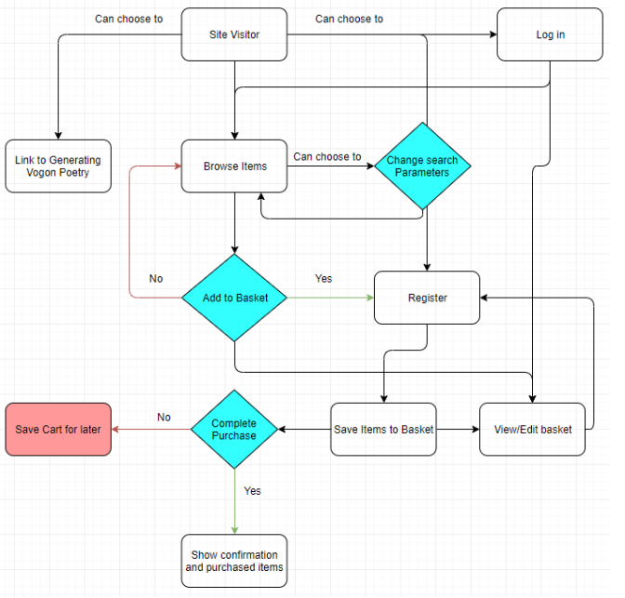

Figure 9 workflow diagram